**Summary Table for Multivariable Linear Regression**

**Macro:** MULTIPLE_LINREG

**Created Date/Author:** March 18, 2013/Dana Nickleach

**Last Update Date/Person**: April 17, 2013/Dana Nickleach

**Current Version**: V2

**Working Environment:** SAS 9.3 English version

**Contact**: Dr. Yuan Liu [yliu31@emory.edu](mailto:yliu31@emory.edu)

**Purpose:** To produce a summary table in a Microsoft Word Document from a multivariable general linear model. The modeling must be done before using this macro.

**Notes:** The regression must be conducted using PROC GLM before calling this macro. Three tables must be created using ODS output when running PROC GLM (nobs, type3, and estimate) as in the example below. The options SOLUTION and CLPARM must also be used in the model statement. Variable names must not be more than 20 characters. This macro is not set up to handle models including interaction terms and will produce incorrect results.

**Parameters:**

|  |  |
| --- | --- |
| **Macro variable** | **Description** |
| DSN | The name of the data set to be analyzed. |
| OUTPATH | File path for output table to be stored. |
| FNAME | File name for output table. |
| FOOTNOTE | Text of footnote to include in the table (optional). It should be in quotes. This footnote will appear below the footnote containing the number of observations. Leave this field blank if not including an additional footnote. |
| TYPE3 | Set to F to suppress type III p-values from being reported in the table (optional). The default value is T. |
| DEBUG | Set to T if running in debug mode (optional). Work datasets will not be deleted in debug mode. This is useful if you are editing the code or want to further manipulate the resulting data sets. The default value is F. |

**Usage Example:**

**DATA** analysis;

input id os_censor Sex $ Age duration os progress $ trt $;

LABEL os = 'Overall Survival (months)'

progress = 'Progression'

trt = 'Treatment'

duration = 'Duration of Radiation';

DATALINES;

1 1 M 40 44 20 No B

2 1 F 45 46 16 Yes A

3 1 F 40 32 20 No B

4 1 F 47 32 23 No B

5 0 M 41 25 22 No B

6 1 M 54 35 13 No B

7 1 M 48 50 9 Yes A

8 1 M 36 33 12 Yes B

9 0 F 49 51 8 Yes A

10 1 M 49 52 10 Yes A

11 1 M 44 35 12 No A

12 1 M 49 50 8 Yes A

13 1 M 44 44 14 Yes A

14 1 M 50 31 10 Yes A

15 1 M 53 40 15 No B

16 0 M 52 29 20 Yes B

17 1 F 46 45 5 Yes A

18 1 F 37 44 11 Yes A

19 1 M 49 46 13 No B

20 1 M 42 31 11 No A

;

ODS OUTPUT NObs = nobs 'Type III Model ANOVA'=type3 ParameterEstimates=estimate;

PROC GLM DATA = analysis;

class trt sex;

model duration = trt sex age/SOLUTION CLPARM;

QUIT;

TITLE 'Table 4 Regression Model';

%MULTIPLE_LINREG(DSN=analysis,

OUTPATH=C:\Users\,

FNAME=Table 4 Regression Model);

TITLE;

**Summary Table Example:**

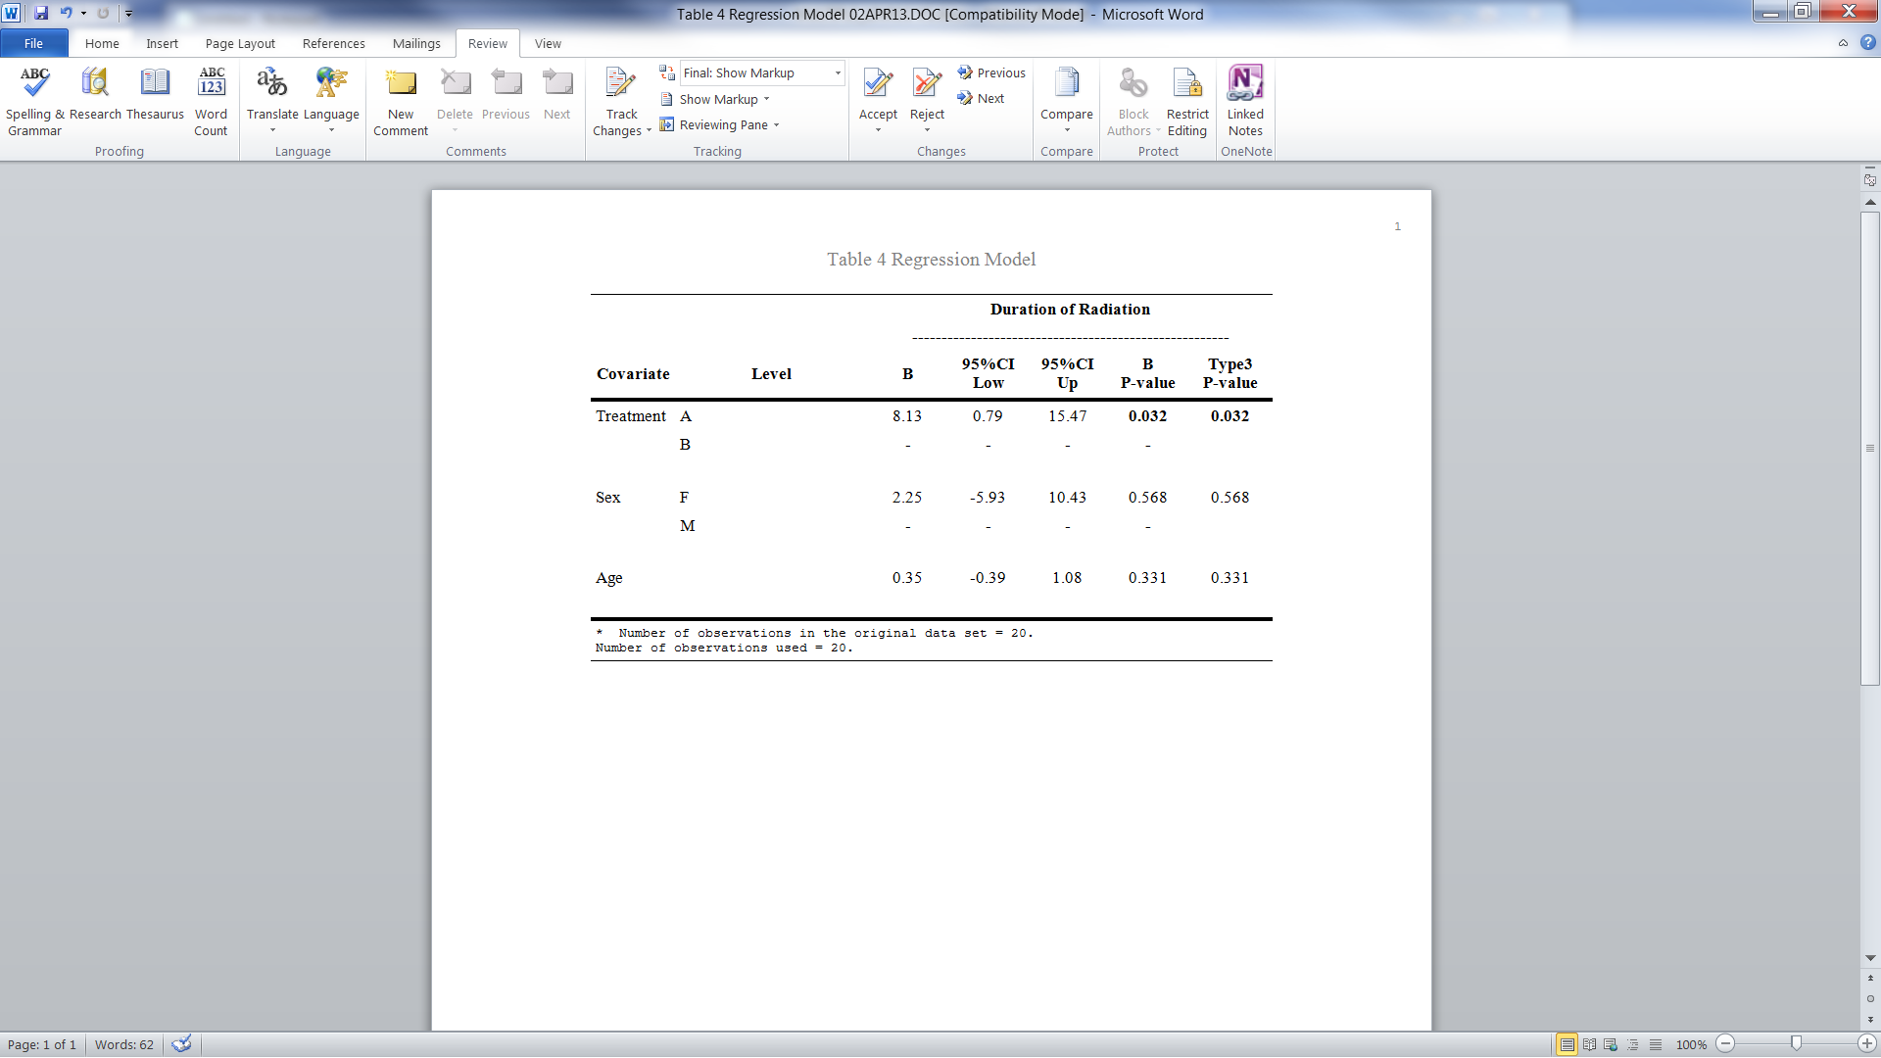

**Permission:**

Permission is hereby granted, free of charge, to any person obtaining a copy of this software and associated documentation files (the "Software"), to deal in the Software without restriction, including without limitation the rights to use, copy, modify, merge, publish, distribute, sublicense, and/or sell copies of the Software, and to permit persons to whom the Software is furnished to do so, subject to the following conditions:   
  
The above copyright notice and this permission notice shall be included in all copies or substantial portions of the Software.  
  
THE SOFTWARE IS PROVIDED "AS IS", WITHOUT WARRANTY OF ANY KIND, EXPRESS OR IMPLIED, INCLUDING BUT NOT LIMITED TO THE WARRANTIES OF MERCHANTABILITY, FITNESS FOR A PARTICULAR PURPOSE AND NONINFRINGEMENT. IN NO EVENT SHALL THE AUTHORS OR COPYRIGHT HOLDERS BE LIABLE FOR ANY CLAIM, DAMAGES OR OTHER LIABILITY, WHETHER IN AN ACTION OF CONTRACT, TORT OR OTHERWISE, ARISING FROM, OUT OF OR IN CONNECTION WITH THE SOFTWARE OR THE USE OR OTHER DEALINGS IN THE SOFTWARE.

**Log of Updates:**

|  |  |  |  |
| --- | --- | --- | --- |
| **Date** | **By** | **Description** | **Version** |
| 3/17/13 | Dana Nickleach ([dnickle@emory.edu](mailto:dnickle@emory.edu)) | Added TYPE3 parameter. | V2 |
|  |  |  |  |
|  |  |  |  |
|  |  |  |  |
|  |  |  |  |